**PHOTOGRAPHS**

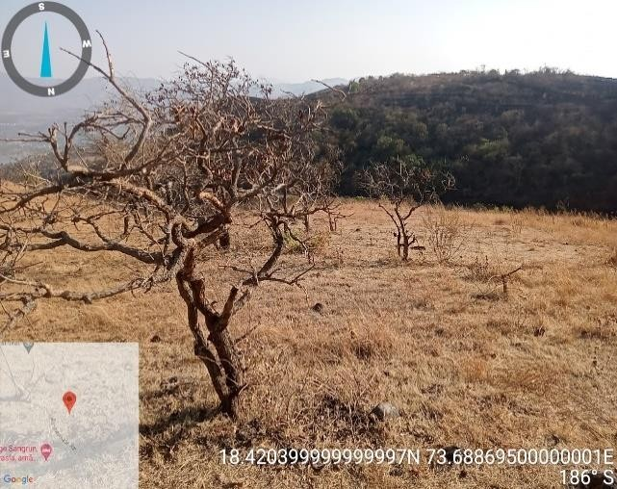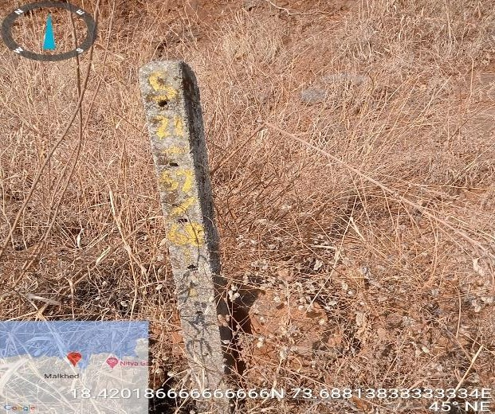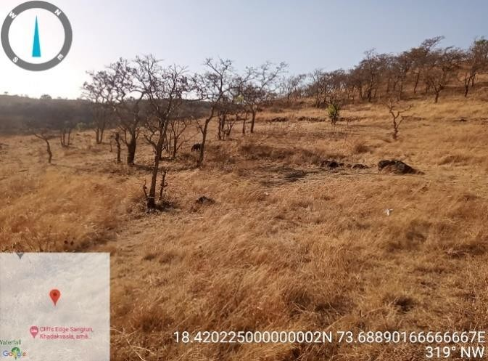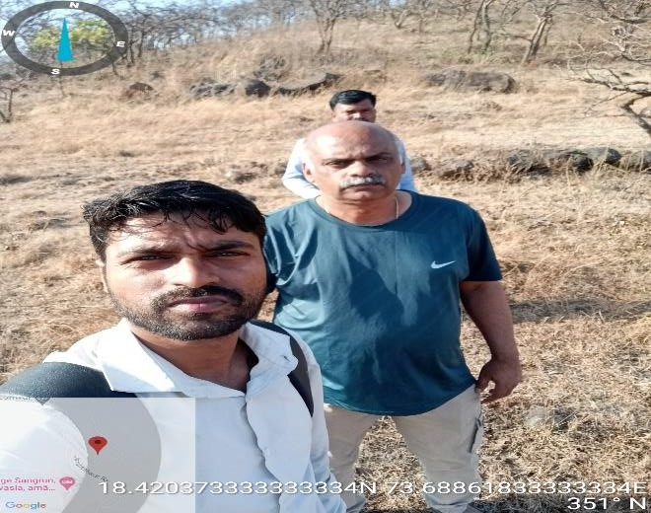

**Customer Name:** - Mr. Sojan jose

**Property Address: -** Plot No. 68, Gat No. 553 To 555, 557 to 571, 573 to 578, 580, 581, 584 To 594,597 To 600, FH 4, Sec No.

21, Situated at Mauje- Mandavi Bk, Taluka- Haveli, District -Pune- 411023

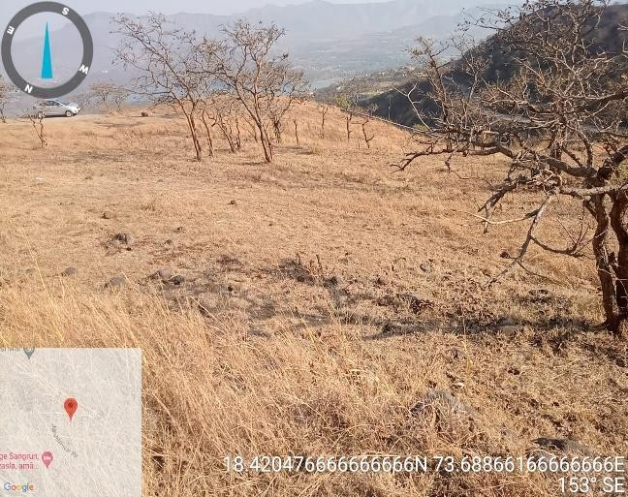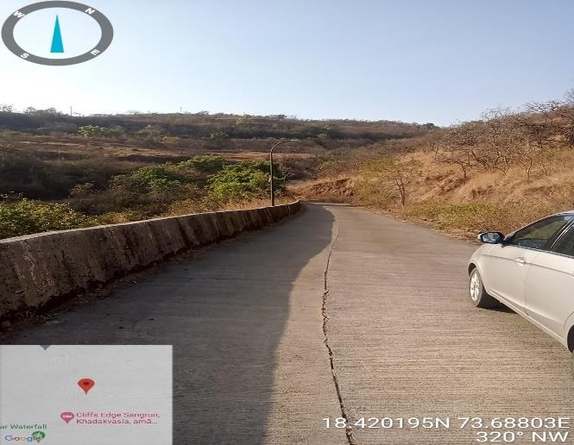

**LOCATION MAP**

**Latitude & Longitude:** 18.420228,73.688190

**Customer Name:** - Mr. Sojan jose

**Property Address:** - Plot No. 68, Gat No. 553 To 555, 557 to 571, 573 to 578, 580, 581, 584 To 594,597 To 600, FH 4, Sec No. 21, Situated at Mauje- Mandavi Bk, Taluka- Haveli, District -Pune- 411023

